CUDDLES N COSMOS

INDEX
- Our Story
- Shipping Policy
- Refund Policy
- Terms of Service
- Custom Design
- Stockists
- Size Guide
- Site Policy
- FAQ
- Contact Us

- OUR STORY

The Company
At Cuddles n Cosmos, we create more than outfits—we craft moments of wonder. Every piece is thoughtfully designed to celebrate childhood, where imagination runs free and every special occasion feels a little more magical.
Rooted in the belief that childhood itself is a celebration, our brand seamlessly blends luxury with whimsy, tradition with modern sensibility, and comfort with couture. We are a luxury occasion wear label for children, crafting dreamy ensembles for tiny trendsetters who love to twirl, sparkle, and steal the spotlight.
Each creation is brought to life through handcrafted details, lush fabrics, and thoughtfully tailored silhouettes—designed to feel as joyful to wear as they are beautiful to behold. From festive collections to bespoke event attire, our process is deeply detail-driven, embracing delicate embroideries, custom silhouettes, soft pastel palettes, and conscious craftsmanship.
Committed to slow fashion and timeless design, every Cuddles n Cosmos piece is made to be cherished—whether it’s a twirl-worthy lehenga or a charming sherwani—capturing memories as precious as the moments they’re worn for.
Thoughtfully designed. Ethically made. Unapologetically magical.
Let’s make every celebration stylishly unforgettable.

ABOUT THE FOUNDER
Rashi Aggarwal, the founder and creative head of Cuddles N Cosmos, brings a heartfelt and design-driven vision to the world of children’s fashion—one that celebrates the magic of childhood through luxury, craftsmanship, and charm. A graduate in Fashion Design, her journey is deeply rooted in a passion for craftsmanship, storytelling, and innovation.
With a keen eye for detail and a deep love for festive elegance, she set out to create a brand where every piece tells a story—of joy, sparkle, and celebration. Her approach blends whimsical imagination with refined design sensibilities, resulting in timeless occasion wear that feels both playful and precious.
Under her creative direction, Cuddles N Cosmos continues to embody a universe where comfort meets couture, and every outfit becomes a moment to remember.

The Name Story of Cuddles N Cosmos
Every brand begins with a moment.
Cuddles N Cosmos began with a feeling.
The quiet warmth of childhood—the comfort of being held close.
And the boundless wonder that lives within it—the sparkle, the curiosity, the belief in magic.
Cuddles speak of softness, of love, of familiarity.
Cosmos evokes imagination, possibility, and a universe without limits.
Together, they define our world.
A space where comfort meets wonder, and childhood is both cherished and celebrated.
Cuddles N Cosmos—a name that holds the poetry of childhood within it.

The Essence Behind the Name
Cuddles N Cosmos is a world created for little dreamers—where clothing is not just worn, but felt.
A place where shimmer meets softness, play meets polish, and celebration is always wrapped in comfort.
Our designs are made for the moments that matter most—the twirls, the laughter, the wide-eyed wonder of festive days.
We don’t simply create outfits.
We craft experiences—stitched with joy, touched with sparkle, and woven with story.

What defines our quality
1. Luxury with Comfort
Thoughtfully designed silhouettes that feel as good as they look—where high-end design never compromises on ease and movement.
2. Festive Couture for Kids
Statement pieces crafted to make every celebration magical, from weddings and festivals to birthdays and milestones.
3. Intricate, Thoughtful Detailing
Refined mirror work, pearls, sequins, and handcrafted embroidery—carefully executed to remain elegant, lightweight, and child-friendly.
4. A Signature Aesthetic
Whimsical yet polished designs, created for families who appreciate premium craftsmanship and timeless style for their little ones.
5. Limited & Curated Collections
Exclusively designed pieces released in thoughtfully curated quantities, ensuring every outfit feels special and one-of-a-kind.
Think couture—reimagined for children: comfortable, wearable, and effortlessly magical.

- SHIPPING POLICY
At Cuddles N Cosmos, every creation is thoughtfully handcrafted and delivered with the same care with which it is made. We partner with trusted logistics providers to ensure your order reaches you safely and seamlessly. This Shipping Policy outlines our order processing, delivery timelines, and shipping terms.
Order Processing
Once your order is placed and payment is successfully confirmed, you will receive an order confirmation email detailing your purchase.
All our pieces are made-to-order and handcrafted with attention to detail. The standard processing time is 7–10 business days, depending on the intricacy of the design.
Custom or bespoke orders may require additional time, which will be communicated at the time of order placement.
For time-sensitive requirements, we recommend connecting with us on WhatsApp at +91 89880 96666 prior to placing your order.
Shipping & Delivery Timelines
Domestic Orders (India)
Orders are typically delivered within 5–7 business days from the date of dispatch.
Please note that delivery timelines are indicative and may vary based on location, weather conditions, or operational delays with our courier partners. While we strive for timely delivery, such delays remain beyond our control.
Shipping Charges
Standard Shipping
Complimentary shipping is offered on most orders within India.
Express Shipping
For expedited delivery, we offer an express shipping option at an additional charge of ₹550 across India.
Express orders are delivered within 10–12 working days. Kindly select this option at checkout if you require priority delivery.
Packaging & Quality Assurance
Each order is elegantly and securely packaged to ensure it arrives in pristine condition.
We request you to inspect your parcel at the time of delivery. In the rare event that the package appears damaged, please do not accept the delivery. Kindly take clear photographs and video of the parcel and share them with us on WhatsApp at +91 89880 96666, allowing us to promptly assess and arrange a replacement.
Please note that claims cannot be accepted once a damaged parcel has been received.
Order Tracking
Once your order is dispatched, tracking details will be shared via email, WhatsApp, or SMS.
You may monitor your shipment using the provided tracking link or through the courier partner’s official website.

- RETURN POLICY
Thank you for choosing Cuddles N Cosmos. Each of our creations is thoughtfully handcrafted and made to order, reflecting our commitment to quality, craftsmanship, and individuality. We request you to remember this while reviewing our Return & Exchange Policy, which outlines the limited circumstances under which exchanges may be offered.
No Refund Policy
At Cuddles N Cosmos, we do not offer refunds under any circumstances.
All purchases are final, and we encourage you to carefully review your order details—including size, color, and design—before placing your order. By completing a purchase with us, you agree to this policy.
Exchange Eligibility
While we strive for perfection in every creation, we understand that on rare occasions, concerns may arise. As all our pieces are custom-made, we follow a carefully considered exchange policy.
Exchanges are accepted only under the following circumstances:
- Manufacturing Defect
In the unlikely event of a manufacturing defect—such as stitching irregularities, assembly errors, or other production-related issues—we will arrange an exchange for the same product.
- Incorrect Product or Color Delivered
If an incorrect product or color is delivered, differing from what was originally ordered, we will gladly exchange it for the correct item.
Conditions for Exchange
To be eligible for an exchange under the circumstances outlined above, the following conditions must be met:
- Mandatory Unboxing Video
A clear, continuous, and unedited unboxing video is required to verify the condition of the product at the time of delivery. The video must clearly show the sealed packaging being opened and the product in its original state, confirming that no damage occurred post-delivery.
- Reporting Timeline
The unboxing video must be shared with us within 24 hours of receiving the product. Requests submitted beyond this timeframe will not be considered.
- Return Shipping Process
Once exchange eligibility is confirmed, we will guide you through the return process. In cases of manufacturing defects or incorrect items, the return shipment will be arranged by us.
Non-Eligible for Exchange
Exchanges cannot be accepted under the following circumstances:
- Incorrect Size, Color or Design Selection
As each piece is custom-made based on your selected specifications, we are unable to offer exchanges for variations arising from personal preferences. We kindly request you to review all selections carefully before placing your order.
- Change of Mind
Exchanges or returns are not permitted if you choose not to retain the product after delivery.
- Used or Damaged Items
Products that have been worn, altered, washed, or damaged after receiving are not eligible for exchange. Any signs of use or mishandling will render the item ineligible.
- Products Not in Original Condition
All items must be returned unused, unaltered, and in their original packaging. Products that do not meet these conditions will not qualify for an exchange.

Exclusions
- Products purchased during sales, promotions, discounts, or clearance offers are not eligible for exchange unless they meet the exchange criteria stated above.
- Customized Products (including personalized designs, prints, or special requests) are not eligible for exchange unless there is a manufacturing defect or an error in customization from our end.

ORDER CANCELLATION
Cancellation and No Refund Policy
At Cuddles N Cosmos, each creation is thoughtfully made to order with the utmost care. While we strive to offer a seamless shopping experience, we understand that occasional changes may be required. Please review our cancellation and no refund policy carefully.
- Cancellation Timeframe
Cancellation requests must be made within 24 hours of placing the order. To initiate a cancellation, please contact us at cuddlesncosmos@gmail.com or WhatsApp us at +91 89880 96666 within this period.
- Credit Note Issuance
For cancellations requested within the specified timeframe, a credit note equal to the full order value will be issued. The credit note is redeemable exclusively on www.cuddlesncosmos.com for future purchases.
- Credit Note Validity: All credit notes are valid for 15 months from the date of issue and the corresponding email notification. Once this period expires, the credit note will no longer be redeemable.
- Cancellation Requests Beyond 24 Hours: Cancellation requests received after 24 hours of order placement cannot be accommodated. Once this period has elapsed, the order proceeds to production and fulfilment, and cancellation or credit note issuance will no longer be possible.
- No Refund Policy: Cuddles N Cosmos follows a strict no refund policy. Monetary refunds are not offered under any circumstances. In place of refunds, eligible cancellations within the allowed timeframe are accommodated through credit notes only.
- Credit Note Redemption:
  - Credit notes are redeemable exclusively on www.cuddlesncosmos.com
  - Credit notes cannot be exchanged for cash, transferred, or combined with other offers
  - Credit notes must be redeemed within the validity period mentioned above

Our Discretion
In rare and exceptional circumstances where an order has not yet been approved or processed by Cuddles N Cosmos, we reserve the right to cancel the order and issue a full refund, in accordance with our standard business practices.
We appreciate your understanding and apologize for any inconvenience this may cause. Transparency and a seamless shopping experience remain at the heart of everything we do. Should you have any questions or require assistance, our customer care team will be pleased to assist you.

Partial COD
For select orders, Cuddles N Cosmos offers a Partial Cash on Delivery (Partial COD) option. Under this facility, customers are required to pay 30% of the total order value in advance to initiate order processing.
Please note the following terms:
- The advance amount paid under the Partial COD facility is non-refundable, non-transferable, and non-adjustable against any other order, design, color, size, or credit note.
- Once the order is confirmed and the advance payment has been received, no cancellations, modifications, or refusal at the time of delivery will qualify for a refund or adjustment of the advance amount.
3. Orders placed under the Partial Cash on Delivery (Partial COD) facility may require additional processing and dispatch time compared to prepaid orders. For time-sensitive deliveries, we recommend choosing prepaid orders to ensure priority processing and timely dispatch.
4. All terms and conditions outlined under Cuddles N Cosmos’ No Exchange / No Return Policy shall apply in full to orders placed using the Partial COD facility.
By placing an order with Cuddles N Cosmos, whether prepaid or under the Partial COD option, the customer acknowledges, understands, and agrees to be bound by all terms and conditions set forth in this Refund & Exchange Policy, as well as any other applicable policies of Cuddles N Cosmos.

TERMS OF SERVICE
Welcome to Cuddles N Cosmos. By accessing or using our website, www.cuddlesncosmos.com, and by placing an order with us, you agree to comply with and be bound by the following Terms of Service. Please read them carefully before using our services.
- Acceptance of Terms
Cuddles N Cosmos is a premium kidswear brand offering handcrafted, made-to-order and customized garments. These Terms of Service govern your use of our website and services. We reserve the right to update or modify these terms at any time without prior notice. Continued use of the website constitutes acceptance of any changes.
- Eligibility
To access or use our Website, you must be at least 18 years of age, or have the consent of a parent or legal guardian. By using this Website, you confirm that you meet this eligibility requirement.
- User Conduct
You agree to use our Website strictly for lawful purposes. In doing so, you shall not:
- Violate any applicable laws or regulations
- Engage in any fraudulent, deceptive, or misleading activities
- Attempt to gain unauthorized access to the Website or interfere with its security or functionality
- Post, share, or distribute any content that is harmful, abusive, offensive, or otherwise inappropriate
We reserve the right to investigate any violation of this provision and to take appropriate action, including removing offending content and suspending or terminating user accounts, as deemed necessary under applicable law.
- User Account
To access certain features of the website, you may be required to create an account. You are responsible for maintaining the confidentiality of your login credentials and for all activities carried out under your account.
Cuddles N Cosmos shall not be liable for any loss arising from unauthorized use of your account.
- Intellectual Property
All content on this website—including images, designs, fabrics, logos, text, graphics, and branding—is the exclusive property of Cuddles N Cosmos and is protected by applicable intellectual property laws. Any unauthorized use, reproduction, or distribution is strictly prohibited.
- Products & Services
All products displayed on our website are handcrafted and made to order. Due to the artisanal nature of our work, slight variations in color, embroidery, or finish may occur and are considered part of the product’s uniqueness.
Customized and bespoke orders are created based on customer specifications and preferences.
If you purchase any products through our Website:
- Prices and product availability are subject to change without prior notice
- We reserve the right to refuse, modify, or cancel any order at our discretion
- All returns, exchanges, and refunds are governed by our applicable Return & Exchange Policy
- Order Acceptance
- Placing an order doesn’t guarantee acceptance.
- Orders are considered confirmed only after payment (full or partial, where applicable) has been successfully received.
- We reserve the right to cancel any order at our discretion, including but not limited to availability, pricing errors, or policy violations.

- Pricing & Payments
All prices are listed in INR unless stated otherwise and are subject to change without prior notice.
We accept prepaid payments and Partial Cash on Delivery (Partial COD) for select orders. Under Partial COD, 30% of the order value must be paid in advance to initiate processing.
The advance paid under Partial COD is non-refundable, non-transferable, and non-adjustable under all circumstances.
- Shipping & Delivery
All shipping and delivery timelines are outlined in our Shipping Policy.
Delivery timelines are indicative and may vary due to factors beyond our control. Cuddles N Cosmos shall not be held responsible for courier delays, weather disruptions, or force majeure events.
- Cancellation, Refunds & Exchanges
- Cuddles N Cosmos follows a strict No Refund Policy.
- Cancellation requests must be made within 24 hours of order placement and are eligible only for a credit note, as per our Cancellation Policy.
- Exchanges are accepted strictly as outlined in our Refund & Exchange Policy.
- All policies apply equally to prepaid and Partial COD orders.
Please review the respective policy pages carefully before placing an order.
- Custom Orders & Alterations
Customized and bespoke orders are created based on customer-approved details. Once confirmed, such orders cannot be cancelled, modified, or exchanged, except in cases of manufacturing defects or errors from our end.
Alterations, fittings, or customization requests are subject to feasibility and approval by our team.
- Third-Party Links
Our website may contain links to third-party websites or services. These links are provided for convenience only. Cuddles N Cosmos does not endorse or assume responsibility for the content, policies, or practices of any third-party platforms.
- Limitation of Liability
To the maximum extent permitted under applicable law, Cuddles N Cosmos shall not be liable for any direct, indirect, incidental, special, or consequential damages arising out of or related to your access to or use of the Website or its services.

- Force Majeure
We shall not be held responsible for delays or failures caused by events beyond our reasonable control, including but not limited to natural disasters, strikes, pandemics, courier disruptions, or governmental actions.
- Termination
We reserve the right, at our sole discretion, to suspend or terminate your access to the Website and its services, with or without prior notice, if we believe you have violated these Terms or engaged in conduct that may harm our business, brand, or reputation. Upon termination, your right to access and use the Website and services will immediately cease.
- Governing Law
These Terms of Service shall be governed by and construed in accordance with the laws of India. Any disputes shall be subject to the exclusive jurisdiction of the courts of India.
- Contact Information
For any questions or concerns regarding these Terms, please contact us at email: cuddlesncosmos@gmail.com
By using our website, you acknowledge and agree to these Terms of Service.

Custom Design
At Cuddles N Cosmos, we believe every child deserves to feel like royalty in an outfit crafted just for them. Our bespoke fitting and customization services are designed to ensure a flawless fit and a truly special experience.

Should you require any adjustments or alterations, simply connect with us via chat or customer support, and our team will be delighted to assist you.

We also offer thoughtful customization options to reflect your child’s unique style. Whether you wish to pair a skirt from one design with a top from another, request a specific color, or personalize an outfit to your preference, our craftsmen will bring your vision to life.

To explore customization or bespoke fitting options, connect with us through chat or support. Let us help you create a one-of-a-kind ensemble that celebrates your child’s individuality.
CHAT NOW

STOCKISTS
Little tags
SIZE GUIDE
Please note: all measurements are body measurements in the standard measurement chart and are measured in inches.
- Girls: Lehenga
(in inches) | Chest Round | Waist Round | Choli Length | Bottom Length
0-3 months | 19 | 18.5 | 8 | 12
3-6 months | 20 | 19.5 | 8.5 | 14
6-12 months | 21 | 20.5 | 9 | 16
1-2 | 23 | 22.5 | 9.5 | 18
2-3 | 25 | 24.5 | 10 | 20
3-4 | 26 | 25.5 | 10.5 | 22
4-5 | 26.5 | 26 | 11 | 24
5-6 | 27 | 26.5 | 11.5 | 26
6-7 | 28 | 27.5 | 12 | 27
7-8 | 29 | 28 | 13 | 28
8-9 | 29 | 28 | 13.5 | 29.5
9-10 | 30 | 28.5 | 14 | 31
10-11 | 30 | 28.5 | 14.5 | 32.25
11-12 | 31 | 29 | 14.5 | 33.5
12-13 | 31 | 29 | 15 | 34.75
13-14 | 32 | 30 | 15 | 35
14-15 | 32 | 30 | 15.5 | 35.75
15-16 | 32 | 30 | 15.5 | 36.5

- Girls: Dress, Gown
(in inches) | Chest Round | Waist Round | Dress Length | Gown Length
0-3 months | 18 | 17 | 15 | 20
3-6 months | 20 | 18 | 17 | 22
6-12 months | 21 | 19 | 18 | 24
1-2 | 23 | 20 | 21 | 28
2-3 | 25 | 22 | 22 | 30
3-4 | 26 | 23 | 24 | 32
4-5 | 26.5 | 24 | 26 | 34
5-6 | 27 | 25 | 27 | 36
6-7 | 28 | 26 | 28 | 38
7-8 | 29 | 27 | 29 | 40
8-9 | 29 | 28 | 30 | 42
9-10 | 30 | 28.5 | 31 | 44
10-11 | 31 | 28.5 | 32 | 46
11-12 | 31 | 29 | 33 | 48
12-13 | 32 | 29 | 34.5 | 49.5
13-14 | 32 | 30 | 36 | 51
14-15 | 34 | 31 | 38 | 52.5
15-16 | 34 | 32 | 38.5 | 53

- Girls: Kurta and Pant
(in Inches) | Chest Round | Waist Round | Kurta Length | Bottom Length
0-3 months | 18 | 17 | 14 | 11.5
3-6 months | 20 | 18 | 16 | 13
6-12 months | 21 | 19 | 18 | 15
1-2 | 23 | 20 | 20 | 17
2-3 | 25 | 22 | 21 | 20
3-4 | 26 | 23 | 22 | 22
4-5 | 26.5 | 24 | 24 | 24
5-6 | 27 | 25 | 26 | 26
6-7 | 28 | 26 | 28 | 27
7-8 | 29 | 27 | 30 | 28
8-9 | 29 | 28 | 32 | 29.5
9-10 | 30 | 28.5 | 34 | 31
10-11 | 31 | 28.5 | 36 | 32.25
11-12 | 31 | 29 | 38 | 33.5
12-13 | 32 | 29 | 39 | 34.75
13-14 | 32 | 30 | 39 | 35
14-15 | 34 | 31 | 40 | 35.75
15-16 | 34 | 32 | 40 | 36.5

- Girls: Kurta and Sharara
(in Inches) | Chest Round | Waist Round | Kurta Length | Bottom Length
0-3 months | 18 | 17 | 14 | 11.5
3-6 months | 20 | 18 | 15 | 13
6-12 months | 21 | 19 | 16 | 15
1-2 | 23 | 20 | 17 | 17
2-3 | 25 | 22 | 19 | 20
3-4 | 26 | 23 | 21 | 22
4-5 | 26.5 | 24 | 23 | 24
5-6 | 27 | 25 | 25 | 26
6-7 | 28 | 26 | 26 | 27
7-8 | 29 | 27 | 27 | 28
8-9 | 29 | 28 | 29.5 | 29.5
9-10 | 30 | 28.5 | 31 | 31
10-11 | 31 | 28.5 | 32 | 32.25
11-12 | 31 | 29 | 32 | 33.5
12-13 | 32 | 29 | 33 | 34.75
13-14 | 32 | 30 | 33 | 35
14-15 | 34 | 31 | 34 | 35.75
15-16 | 34 | 32 | 34 | 36.5

- Girls: Crop top, Pant and Shrug
(in inches) | Chest Round | Waist Round | Crop Top Length | Bottom Length | Shrug Length
0-3 months | 18 | 17 | 5 | 11.5 | 10
3-6 months | 20 | 18 | 6 | 13 | 12
6-12 months | 21 | 19 | 6.5 | 15 | 14
1-2 | 23 | 20 | 7 | 17 | 16
2-3 | 25 | 22 | 7.5 | 20 | 20
3-4 | 26 | 23 | 8.5 | 22 | 24
4-5 | 26.5 | 24 | 9 | 24 | 25
5-6 | 27 | 25 | 9 | 26 | 27
6-7 | 28 | 26 | 9.5 | 27 | 29
7-8 | 29 | 27 | 10.5 | 28 | 30
8-9 | 29 | 28 | 10.5 | 29.5 | 31
9-10 | 30 | 28.5 | 11 | 31 | 33
10-11 | 31 | 28.5 | 11.5 | 32.25 | 34
11-12 | 31 | 29 | 12.5 | 33.5 | 35
12-13 | 32 | 29 | 13 | 34.75 | 36
13-14 | 32 | 30 | 14 | 35 | 38
14-15 | 34 | 31 | 15 | 35.75 | 39
15-16 | 34 | 32 | 16 | 36.5 | 40

- Boys: Kurta and Pyjama
(in Inches) | Chest Round | Waist Round | Kurta Length | Pant Length
0-3 months | 20 | 18 | 13 | 15
3-6 months | 21 | 19 | 14 | 15.5
6-9 months | 21.5 | 20 | 15 | 16
9-12 months | 22 | 21 | 16 | 17
1-2 | 24 | 22 | 19 | 18
2-3 | 25 | 23 | 21 | 20
3-4 | 26 | 24 | 22 | 21
4-5 | 27 | 25 | 24 | 23
5-6 | 28 | 26 | 26 | 24
6-7 | 29 | 27 | 27 | 26
7-8 | 30 | 28 | 28 | 27
8-9 | 31 | 29 | 30 | 29
9-10 | 32 | 30 | 32 | 30
10-11 | 33 | 31 | 34 | 32
11-12 | 34 | 32 | 36 | 34
12-13 | 35 | 33 | 38 | 36
13-14 | 36 | 34 | 40 | 37
14-15 | 37 | 35 | 42 | 38
15-16 | 38 | 36 | 44 | 40

- Boys: Kurta, Pyjama and Jacket
(in Inches) | Chest Round | Waist Round | Bundi Length | Kurta Length | Pant Length
0-3 months | 20 | 18 | 10.5 | 13 | 15
3-6 months | 21 | 19 | 11.5 | 14 | 15.5
6-9 months | 21.5 | 20 | 12 | 15 | 16
9-12 months | 22 | 21 | 12.5 | 16 | 17
1-2 | 24 | 22 | 13.5 | 19 | 18
2-3 | 25 | 23 | 15 | 21 | 20
3-4 | 26 | 24 | 16 | 22 | 21
4-5 | 27 | 25 | 17 | 24 | 23
5-6 | 28 | 26 | 18 | 26 | 24
6-7 | 29 | 27 | 19 | 27 | 26
7-8 | 30 | 28 | 20 | 28 | 27
8-9 | 31 | 29 | 21 | 30 | 29
9-10 | 32 | 30 | 21.5 | 32 | 30
10-11 | 33 | 31 | 22 | 34 | 32
11-12 | 34 | 32 | 22.5 | 36 | 34
12-13 | 35 | 33 | 23 | 38 | 36
13-14 | 36 | 34 | 23.5 | 40 | 37
14-15 | 37 | 35 | 24 | 42 | 38
15-16 | 38 | 36 | 24.5 | 44 | 40

From the above measurement, 3-4 inches of extra margin for the same for later use.
Followed with a tab to CHAT NOW

- SITE POLICY
At Cuddles N Cosmos, your privacy is important to us. This Privacy Policy explains how we collect, use, and protect your personal information when you access or use our website and services.
By choosing to use our website or services, you agree to the collection and use of information in accordance with this Privacy Policy. Any personal information collected is used solely to provide, operate, and improve our services and will not be shared except as outlined below.
Information Collection & Use
To enhance your experience with us, we may request certain personally identifiable information, including but not limited to your name, phone number, email address, and postal address. This information is used to process orders, communicate with you, and provide customer support.
Log Data
Whenever you visit our website, we may collect information sent by your browser, known as Log Data. This may include your IP address, browser type and version, pages visited, date and time of your visit, time spent on pages, and other analytical data used to improve website performance.
Cookies
Cookies are small data files stored on your device to help enhance your browsing experience. Our website uses cookies to collect information and improve functionality.
You may choose to accept or decline cookies through your browser settings. Please note that disabling cookies may limit access to certain features of our website.
Service Providers
We may engage trusted third-party service providers to:
- Facilitate our services
- Perform service-related tasks on our behalf
- Assist in analyzing website usage and performance
These third parties may have access to your personal information strictly for the purpose of performing assigned tasks and are contractually obligated to maintain confidentiality and not use the information for any other purpose.
Data Security
We value your trust and take reasonable measures to protect your personal information using commercially acceptable security practices. However, please note that no method of transmission over the internet or electronic storage is completely secure, and absolute security cannot be guaranteed.
Links to External Websites
Our website may contain links to third-party websites. Once you leave our site, we are not responsible for the privacy practices, content, or policies of external websites. We encourage you to review the privacy policies of any third-party sites you visit.
Children’s Privacy
The Services are not intended for use by children, and we do not knowingly collect personal information from children. If you are a parent or legal guardian and believe that a child has shared personal information with us, you may contact us using the details provided below, and we will promptly take steps to delete such information.
As of the effective date of this Privacy Policy, we do not knowingly sell or share (as defined under applicable law) the personal information of individuals under the age of 16.
Updates to This Privacy Policy
We may update this Privacy Policy periodically. Any changes will be posted on this page and will take effect immediately upon publication. We encourage you to review this page regularly to stay informed.
CONTACT US
If you have any questions or suggestions about our Privacy Policy, do not hesitate to contact us.

FAQs
Q: What age group does your kidswear collection cater to?
Our collection is thoughtfully designed for children aged 1 to 16 years, offering elegant styles for both toddlers and older children.
Q: How can I determine the right size for my child?
A detailed size chart is available on each product page to help you choose the best fit. If you require further assistance, feel free to share your child’s measurements with us, and our team will be happy to guide you.
Q: How long does it take to process an order?
All our pieces are handcrafted and made to order. Processing typically takes 7–10 business days. Once your order is shipped, tracking details will be shared with you.
Q: How do I place a custom order?
To place a custom order, please contact our customer support team via WhatsApp. Our executive will assist you throughout the customization process.
Q: Can I make changes to an order once it has been placed?
Orders are processed shortly after placement. If you wish to request changes, please contact us within 24 hours of placing your order. While we will do our best to assist, changes cannot be guaranteed once production has begun or the order has been dispatched.
Q: Do you offer international shipping?
Yes, we ship internationally to select countries. Shipping charges and delivery timelines vary based on location. Please reach out to us via WhatsApp to place an international order.
Q: How do I register on the website?
You can create an account by registering with your email address and setting a password.
Q: I’ve forgotten my password. How can I reset it?
Simply click on “Forgot Password” on the login page and follow the instructions sent to your registered email address to reset your password.
Q: How can I update my personal details or shipping address?
Log in to your account and navigate to “My Account” to update your personal information or shipping address.
Q: I need help deciding what to buy. Can I speak to a stylist?
Absolutely. Our in-house stylists are happy to assist with outfit selection, color guidance, and occasion-specific styling.
For styling assistance, please email us at cuddlesncosmos@gmail.com or WhatsApp us at +91 89880 96666, Monday to Saturday, 10:00 AM – 6:00 PM (IST).
Q: Are the colors shown on the website accurate?
We make every effort to display garment colors as accurately as possible. However, slight variations may occur due to screen settings, device variations or the handcrafted nature of embroidered pieces.
Q: Still have a question?
If you couldn’t find what you were looking for, please email us at cuddlesncosmos@gmail.com, and we’ll respond within 48 hours. You may also contact us via WhatsApp at +91 89880-96666, Monday to Saturday, 10:00 AM – 6:00 PM (IST).

- CONTACT US

Phone
+91 8988096666

Email
hello@cuddlesncosmos.com

WhatsApp
+91 8988096666

Girls: Lehenga
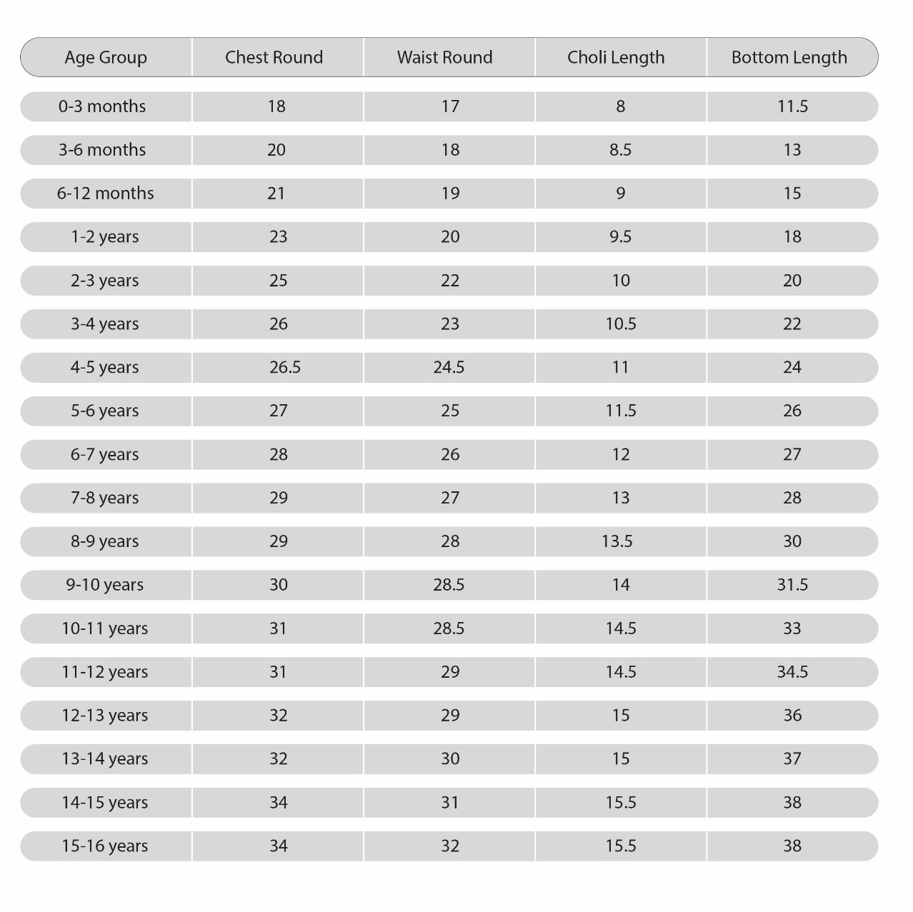
Please note: These are garment measurements in the standard measurement chart and are measured in inches.
Girls: Kurta and Sharara
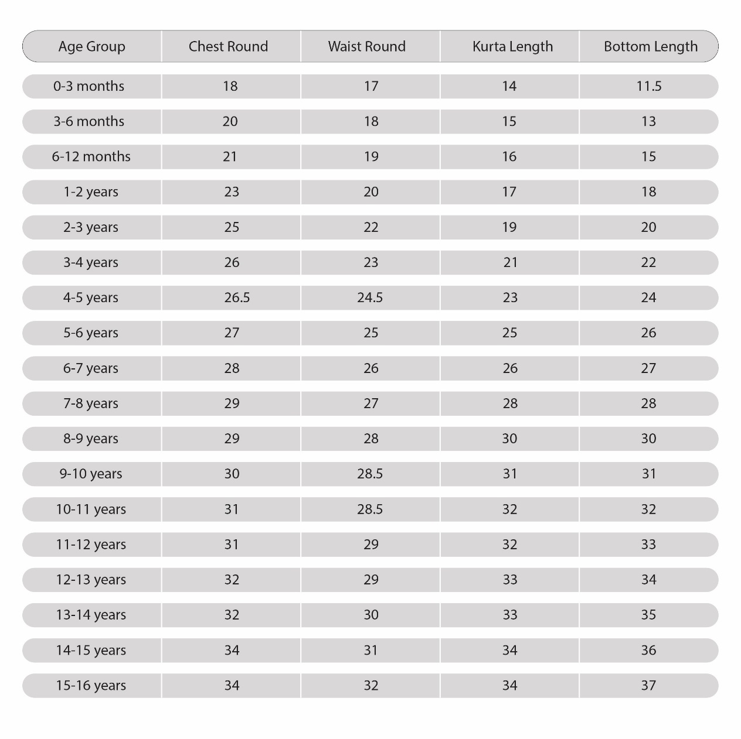
Please note: These are garment measurements in the standard measurement chart and are measured in inches.
Girls: Kurta and Pant
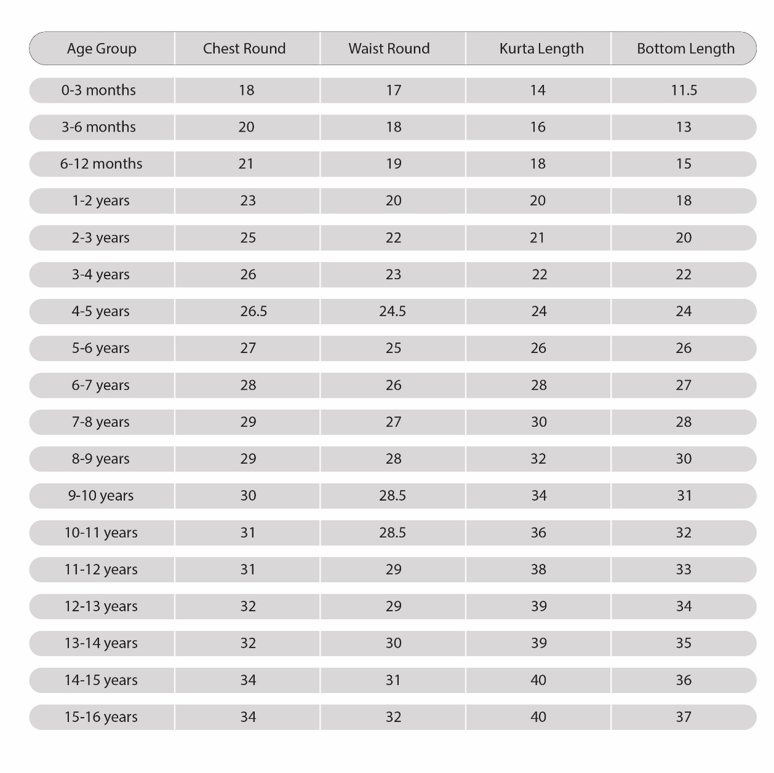
Please note: These are garment measurements in the standard measurement chart and are measured in inches.
Girls: Crop top, Pant and Shrug
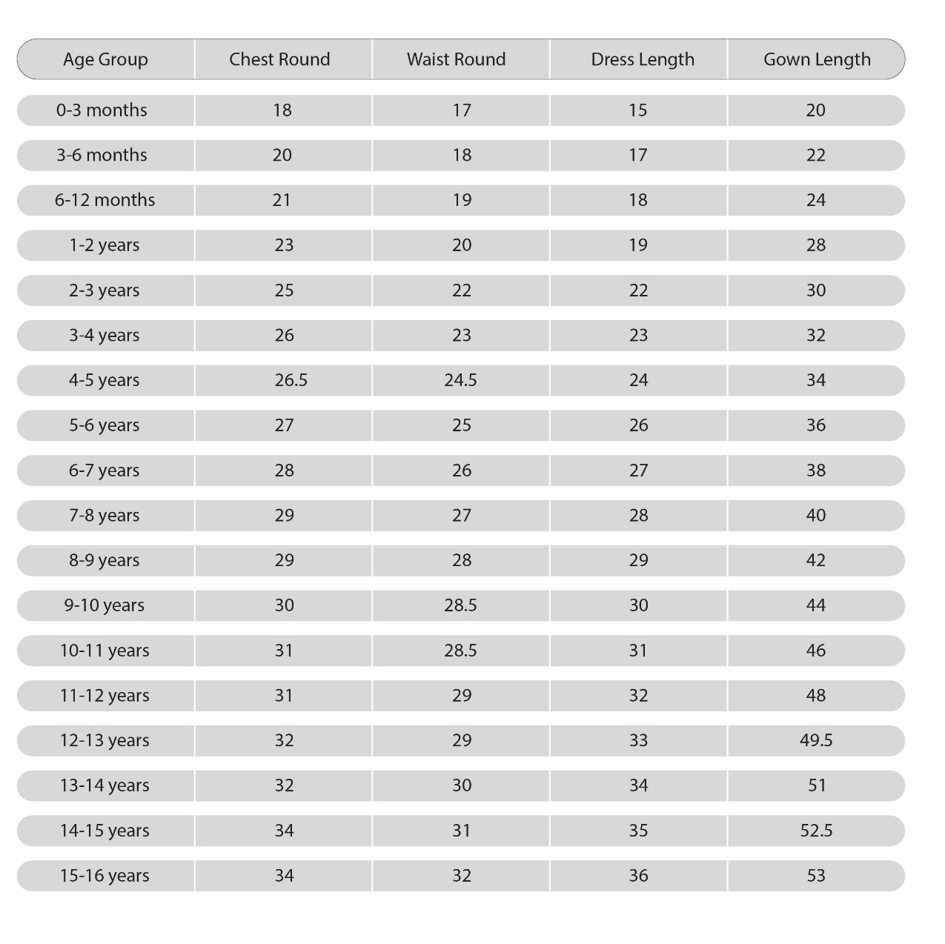
Please note: These are garment measurements in the standard measurement chart and are measured in inches.
Girls: Dresses and Gown
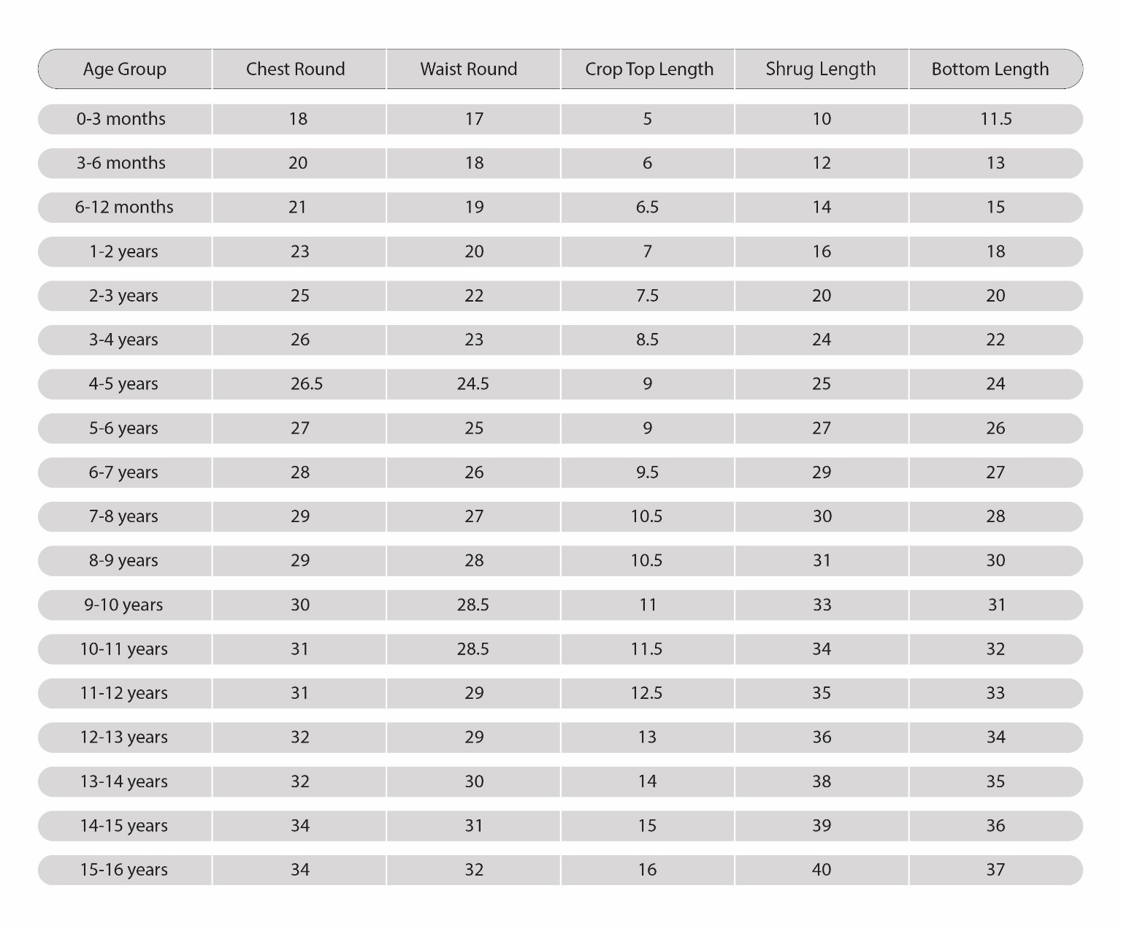
Please note: These are garment measurements in the standard measurement chart and are measured in inches.
Boys: Kurta with Pyjama

Boys: Kurta, Pyjama and Jacket

